Ontology-based Expert System for a Generic Drug Production of Pharmaceutical Dosage Forms

Project Plan

By

**Mr. Narongrit Saisuwan 542115017**

**Mr. Panupak Wichaidit 542115047**

Department of Software Engineering

College of Arts, Media and Technology

Chiang Mai University

Project Advisor

………………………………………..

**Dr. Chartchai Doungsa-ard**

# Document History

|  |  |  |  |  |  |  |
| --- | --- | --- | --- | --- | --- | --- |
| **Document Name** | **Version** | **Status** | **Date** | **Viewable** | **Reviewer** | **Responsible** |
| **Documents** | | | | | | |
| **OEGP –Project Plan_ v0.1.docx** | **0.1**   * Introduction * System Architecture * Deliverables and Limit * Schedule & Milestones | Draft | June 30, 2014 | NS, PW, CD | NS, PW | NS, PW |
| **OEGP –Project Plan_v0.2.docx** | **0.2**   * Deliverables and Limit * Schedule & Milestones * Infrastructure * Management Procedures * Version Control Strategy | Draft | July 5, 2014 | NS, PW, CD | NS, PW | NS, PW |

Table of Contents

Document History ii

Chapter 1 | Introduction 1

1.1 Identification 1

1.2 Project Overview 1

1.2.1-Motivation 1

1.2.2-Aim 1

1.2.3-Objective 1

Chapter 2 | System Architecture 2

2.1.1 System Architecture 2

2.1.2 System Architecture Overview 3

2.1.3 Limit 4

Chapter 3 | Deliverables 5

3.1 Deliverables 5

Chapter 4 | Acronyms and Definitions 6

4.1 Acronyms 6

4.2 Definitions 6

Chapter 5 | Infrastructure 7

5.1 Software Development Life Cycle 7

5.2 Software Acquisition Plans 8

5.2.1 Design Tools 8

5.2.2 Development Tools 8

5.2.3 Configuration Management Tools 8

5.2.4 Document Tools 8

5.2.5 Testing Tools 8

5.3 Hardware and Material Resources 8

Chapter 6 | Management Procedures 9

5.1 Project Team Structure 9

5.2 Monitoring and Controlling Mechanisms 9

5.2.1 Project Meeting 9

Chapter 7 | Quality Standard 10

4.1 ISO 29110 for Very Small Entity (VSE) 10

4.1.1 Project Management (PM) process 10

4.1.2 Software Implementation (SI) process 12

Chapter 8 | Quality Planning 14

8.1 Quality Factors 14

8.1.1 Product operation factors 14

8.1.2 Product revision factors 14

8.1.3 Product transition factors 14

8.2 Reviews/Responsibility 15

Chapter 9 | Schedule & Milestones 16

9.1 Schedule Plan 16

9.1 Milestones 18

Chapter 10 | Version Control Strategy 21

10.1 Naming Conversion 21

7.2 Project Repository 22

7.3 Configuration Item Table 23

Chapter 11 | Risk Management 24

11.1 Risk Management Process 24

11.2 Risk Identification and Solutions 25

# Chapter 1 | Introduction

## Identification

Project Plan is the document for planning, scheduling activities and evaluating overall of the project so that the project will complete as successfully as possible in spite of all the risks. The Project Management will lead us to see specific project reach fruition and allow us to work with it and see a project through from start to finish.

## Project Overview

### 1.2.1-Motivation

The price of original drugs, which is under patent protection, is always expensive because of research and development costs. So this reasons make poor people, in developing countries, cannot pay for curing their sickness or disease. For solve this problem, the local pharmaceutical corporations try to develop a new drug manufacturing that call reformulating drugs into a generic version after the patent protection expired.

The pharmaceutical formulation process is a highly specialize task requiring specific domain knowledge and often years of experience. Expert system derived from research into artificial intelligence support the efficient formulation of products and therefore increase productivity, consistency and quality.

Follow the issue above, Ontology-based Expert System for a Generic Drug Production of Pharmaceutical Dosage Forms can help an inexperienced industry pharmacists to reproduce a generic drug in the right way and the right time.

### 1.2.2-Aim

The aim of this project is to develop mobile application on Tablet computer. Ontology-based Expert System for a Generic Drug Production of Pharmaceutical Dosage Forms recommend a solution for reformulating an original drug into a generic version. The generic production receives a pharmaceutical value and shows result as a drug formula, manufacturing and excipients. The experience pharmacist can use Ontology-based Expert System for a Generic Drug Production of Pharmaceutical Dosage Forms for reformulating drug.

### 1.2.3-Objective

* To recommend a generic production that consist of a formula and its instructions.
* To evaluate the generic drug production comparing with the original drug.
* To suggestion the generic production, which is not equivalent to the original drug, until it equivalent to its original.

# Chapter 2 | System Architecture

## 2.1.1 System Architecture

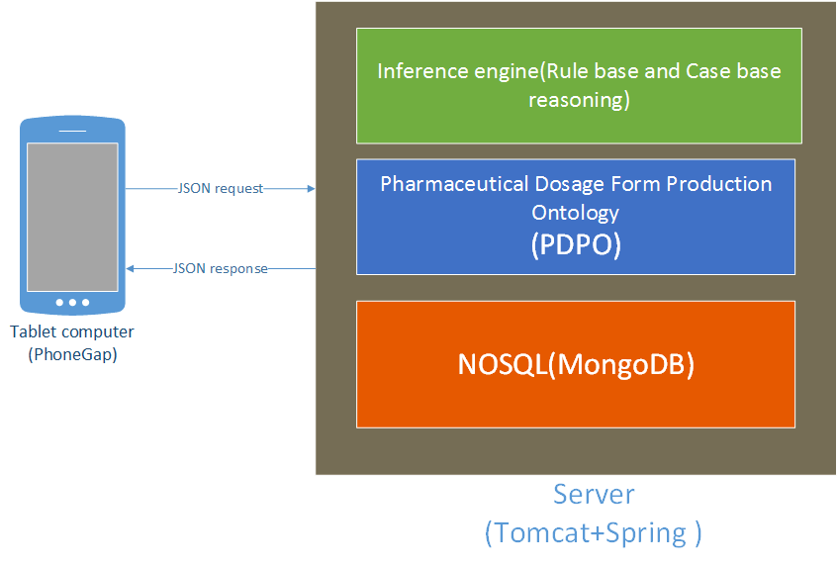

**Figure 1: System Architecture.**

Figure 9 show the system architecture of Ontology-based Expert System for a Generic Drug Production of Pharmaceutical Dosage Forms. Firstly, the system receives an input data from a user via tablet computer. Then it send the data to the server in JSON format. After that, the system on server will recommend an appropriate solutions using rule base technique and/or case base reasoning. Finally the system returns a drugs reformulation with manufacturing and excipients to the user.

## 2.1.2 System Architecture Overview

From the system architecture on Figure 8, Ontology-based Expert System for a Generic Drug Production of Pharmaceutical Dosage Forms can be divided into many subsystem such as the user management system, the rule base system, the case base reasoning system, hybrid reasoning system and the pharmaceutical tablet production on ontology. The server side is develop on JAVA programming and with apache server. The structure of architecture overview is illustrated in Figure 10

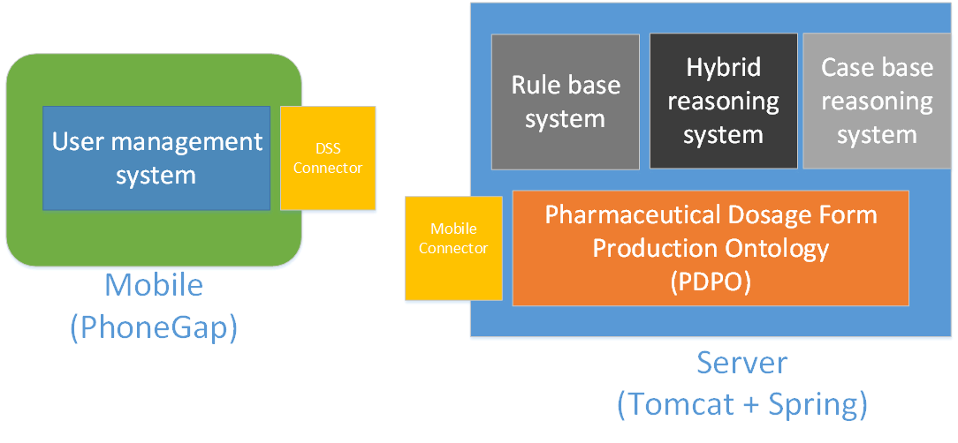

**Figure 2: System Architecture overview**

The subsystem can group into two main parts. The first one is a mobile part, and the second is a server part.

###### Mobile Part

* **Feature 1 : User management system**

There are two types of users in Ontology-based Expert System for a Generic Drug Production of Pharmaceutical Dosage Forms. The first one is experience pharmacists. This user uses the system for evaluating generic drugs production comparing with the original drug production. The experience pharmacists also use the system for suggested an appropriate manufacturing and excipients to reformulate a drug and they can create and/or add a new case by themselves. The second is inexperience pharmacists. This user uses the system similar with experience pharmacists, but they cannot add add/or create any of a new pharmaceutical case.

###### Server part

* **Feature 2 : Rule base system**

Rule base system is one part of inference engine that using for suggesting the reformulate an original drug as a generic version. Rule base system can decide a drug reformulating by “rule “. The rule is come from a set of pharmaceutical knowledge that call PDPO (Pharmaceutical dosage form production ontology). The rule base system receive a pharmaceutical value and show an appropriate result as a manufacturing and excipient to the user.

* **Feature 3 : Case base reasoning system**

Case base reasoning system is one part of inference engine like a Rule base system. Ontology-based Expert System for a Generic Drug Production of Pharmaceutical Dosage Forms uses a case base reasoning system for reformulating an original drug and comparing the generic drug production with original drug production. The experience pharmacists can use the case base reasoning system for creating and adding a new case into the system. The new case base used to reformulate an original drug like existing case base.

* **Feature 4: Hybrid reasoning system**

Hybrid reasoning system is an inference engine that combine with Case base reasoning and Rule base system. The system is suggest to reformulate an original drug into a generic version. The pharmacists can use the hybrid reasoning system for creating and adding a new case into the system like Case base reasoning system.

* **Feature 5 : Pharmaceutical Dosage Form Production Ontology system(PDPO system)**

PDPO system is kept as set of knowledge. The rule base and the case base reasoning use PDPD for calculating an appropriate reformulate drugs the reformulate an original drug as generic version.

* **Feature 6 : DSS connector**

DSS connector is a system at mobile part which sending and receiving a data between users and a server. DSS connector receive a data from a user interface and send data to PDPO for find a drug reformulation Additionally, DSS connector can receive a result from PDPO and show it to a user.

* **Feature 7 : Mobile connector**

Mobile connector is a system at server part which sending and receiving a data between users and a server. Mobile connector receive an input data from mobile part and send data to PDPO for suggesting a reformulate original drugs as generic drug production; furthermore Mobile connector sends a result to mobile part.

## 2.1.3 Limit

* The user require a Tablet computer and internet connection.
* Ontology-based Expert System for a Generic Drug Production of Pharmaceutical Dosage Forms is appropriated with a person who has a pharmacy knowledge.

# Chapter 3 | Deliverables

### 3.1 Deliverables

|  |  |  |  |  |
| --- | --- | --- | --- | --- |
| **No.** | **Deliverables/Release** | **Media** | **Copies** | **Date** |
| 1 | Project Proposal   * Proposal Version | Document | 3 | 6th Mar 2014 |
| 2 | Progress Report 1   * Project Plan Version 1.0 * Software Requirement Specification Version 1.0 * Software Design Document Version 1.0 * Test Plan Version 1.0 * Traceability Record Version 1.0 * Software Version 1.0 | Document  Document  Document  Document  Document  Source code | 3  3  3  3  3  1 | 7th July 2014 |
| 3 | Progress Report 2   * Project Plan Version 2.0 * Software Requirement Specification Version 2.0 * Software Design Document Version 2.0 * Test Plan Version 2.0 * Traceability Record Version 2.0 * Software Version 2.0 | Document  Document  Document  Document  Document  Source code | 3  3  3  3  3  1 | 3rd September 2014 |
| 4 | Progress Report 3   * Project Plan Version 3.0 * Software Requirement Specification Version 3.0 * Software Design Document Version 3.0 * Test Plan Version 3.0 * Traceability Record Version 3.0 * Software Version 3.0 * Software Source Code * Show Pro Event   + Software Version 2.0   + 30 Seconds Video   + Poster size A1   + User Manual | Document  Document  Document  Document  Document  Source code  CD-ROM  File  File  Poster  File | 3  3  3  3  3  1  1  1  1  1  1 | 26th Nov 2014  3rd December 2014  5th November 2014 |

# Chapter 4 | Acronyms and Definitions

## 4.1 Acronyms

|  |  |
| --- | --- |
| SRS | Software Requirement Specification |
| URS | User Requirement Specification |
| SDD | Software Design Document |
| OS | Operating System |
| VSE | Very Small Entity |
| PM | Project Management |
| SI | Software Implementation |
| IID | Iterative and Incremental Development |
| SCI | Software Configuration Item |
| OEGP | Ontology-based Expert System for a Generic Drug Production of Pharmaceutical Dosage Forms |
| PDPO | Pharmaceutical Dosage Form Production Ontology |

## 4.2 Definitions

|  |  |
| --- | --- |
| **Name** | **Definition** |
| Acceptance test | Test activities for sample checks to verify that a system (or product, solution) has the right quality for deployment or usage. Often acceptance test is done by the customer. [IEEE90] |
| Feature | Transformation of input parameters to output parameters based on a specified algorithm. It describes the functionality of a product in the language of the product. Used for requirements analysis, design, coding, testing or maintenance. [IEEE90] |
| IEEE | Institute for Electrical and Electronics Engineers. Biggest global interest group for engineers of different branches and for computer scientists. [IEEE90] |
| Plan | A documented series of tasks requires meeting an objective, typically including the associated schedule, budget, resources, organizational description and work breakdown structure. [IEEE90] |
| Project Management | The application of knowledge, skills, tools, and techniques to project activities in order to meet or exceed stakeholder needs and expectations from a project. [IEEE90] |
| Project Plan | A formal, approved document used to guide both project execution and project control. The primary uses of the project plan are to document planning assumptions and decision, to facilitate communication among stakeholders, and to document approved scope, cost, and schedule baseline. [IEEE90] |
| Risk | An uncertain event or condition that, if it occurs, has a positive or negative effect on a project’s objectives. It is a function of the probability of occurrence of a given threat’s occurrence. [IEEE90] |
| Risk Management | The systematic application of management policies, procedures and practices to the tasks of identifying, analyzing, evaluating, treating and monitoring risk. [IEEE90] |

# Chapter 5 | Infrastructure

## 5.1 Software Development Life Cycle

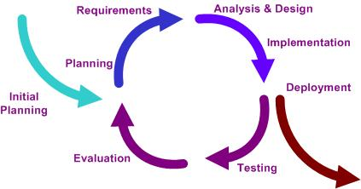

**Figure 3 Iterative Development Model**

Figure 1 presents a method of software development. Iterative development model is a cyclic software development process developed in response to the weaknesses of the Waterfall model. The model starts with planning and continues through iterative development cycles.

Ontology-based Expert System for a Generic Drug Production of Pharmaceutical Dosage Forms. Developer can use model to develop the iterative way to fulfill, change software and document for each development process.

## 5.2 Software Acquisition Plans

### 5.2.1 Design Tools

* Photoshop CS6
* Adobe Dreamweaver CS6

### 5.2.2 Development Tools

* Eclipse Kepler
* IntelliJ 12.1.6

### Configuration Management Tools

* GitHub

### 5.2.4 Document Tools

* Microsoft Word 2013

### 5.2.5 Testing Tools

* IPad 2
* Notebook with Google chrome or Firefox browser
* Host Server

## 5.3 Hardware and Material Resources

* **Internet**
* **Computers**
  + Apple Macbook Pro mid 2013
    - Processor: Intel® Core™ i7-3520M CPU @ 2.90GHz 2.90GHz
    - RAM: 8.00 GB
    - Operating System: Windows 7 Ultimate, OSX maverick
  + Dell Inspiron n5110
* Processor: Intel® Core™ i5-2410M CPU @ 2.30GHz 2.30GHz
* RAM: 4.00 GB
* Operating System: Windows 8.1 Professional
* **Tablet Computer**
  + Ipad 2

# Chapter 6 | Management Procedures

## 5.1 Project Team Structure

|  |  |
| --- | --- |
| **Participants** | **Activities** |
| Mr. Panupak Wichaidit  And  Mr. Narongrit Saisuwan | Feasibility Study |
| Project Proposal |
| Project Requirements |
| Project Plan |
| Project Design |
| Implementation |
| Testing |

## 5.2 Monitoring and Controlling Mechanisms

### 5.2.1 Project Meeting

|  |  |
| --- | --- |
| **Participants** | **Roles** |
| Mr. Panupak Wichaidit | Development team member |
| Mr. Narongrit Saisuwan | Development team member |
| Aj. Chartchai Doungsa-ard | Project advisor |

# Chapter 7 | Quality Standard

## 4.1 ISO 29110 for Very Small Entity (VSE)

ISO 29110 is the Software Life Cycle Profiles and Guidelines for Very Small Entities (VSEs) standards and technical reports are targeted at Very Small Entities (VSEs). A Very Small Entity (VSE) is an enterprise, organization, department or project having up to 25 people. ISO 29110 concerns on project management process and software implementation process.

### 4.1.1 Project Management (PM) process

* **Purpose**

The purpose of the Project Management process is to establish and carry out in a systematic way the tasks of the software implementation project, which allows complying with the project’s objectives in the expected quality, time and costs.

* **Objectives**
  + **PM.O1**. The Project Plan for the execution of the project is developed according to the Statement of Workand validated with the Customer. The tasks and resources necessary to complete the work are sized and estimated.
* **PM.O1. Tasks in this project:**

1. Create the Project Plan related with the Project Proposal.

* + **PM.O2.** Progress of the project is monitored against the *Project Plan* and recorded in the Progress Status Record. Corrections to remediate problems and deviations from the plan are taken when project targets are not achieved. Appropriate treatment is taken to correct or avoid the impact of risk. Closure of the project is performed to get the Customer acceptance documented in the *Acceptance Record*
    - **PM.O2. Tasks in this project:**

1. Record the project status in Project Status Record for each progress.

2. Establish the Acceptance Record before submitting final progress.

* + **PM.O3.** The Change Requests are addressed through their reception and analysis. Changes to software requirements are evaluated for cost, schedule and technical impact.
    - **PM.O3. Tasks in this project:**

1. Analyzing the change.

2. Setting the change request form.

3. Approving the change request by project advisor.

4. Change the project follow by approved change request.

* + **PM.O4.** Review meetings with the Work Team and the Customer are held. Agreements are registered and tracked.
    - **PM.O4. Tasks in this project:**

1. Meeting with team members and project advisor.

2. Evaluate meeting results.

* + **PM.O5.** Risks are identified as they develop and during the conduct of the project.
    - **PM.O5. Tasks in this project:**

1. Identify the risks.

2. Analyse the risks.

3. Plan for managing the risksin the Project Plan.

* + **PM.O6.** A Software Version Control Strategy is developed. Items of *Software Configuration* are identified, defined and base lined. Modifications and releases of the items are controlled and made available to the Customer and Work Team including the storage, handling and delivery of the items.
    - **PM.O6. Tasks in this project:**

1. Identify SCI.

2. Create SCI table.

3. Record the change of each SCI in the SCI table.

* + **PM.O7.** Software Quality Assurance is performed to provide assurance that work products and processes comply with the *Project Plan* and *Requirements Specification*.
    - **PM.O7. Tasks in this project:**

1. Create tasks follow ISO29110 for VSE to the Project Plan and Requirements Specification.

### Software Implementation (SI) process

* **Purpose**

The purpose of the Software Implementation process is the systematic performance of the analysis, design, construction, integration and tests activities for new or modified software products according to the specified requirements.

* **Objectives**
  + **SI.O1.** Tasks of the activities are performed through the accomplishment of the current Project Plan.
    - **SI.O1. Tasks in this project:**

1. Develop software comply with the current Project Plan.
   * **SI.O2.** Software requirements are defined, analysed for correctness and testability, approved by the Customer, base lined and communicated.
     + **SI.O2. Tasks in this project:**

1. Analyse the requirements.

2. Accomplish the Software Requirements Specification.

* + **SI.O3.** Software architectural and detailed design is developed and base lined. It describes the software items and internal and external interfaces of them. Consistency and traceability to software requirements are established.
    - **SI.O3. Tasks in this project:**

1. Create Software Design Document that covers all of Software Requirements.

2. Create Traceability Record to trace the items in Software Design Document with the software requirements.

* + **SI.O4.** Software components defined by the design are produced. Unit test are defined and performed to verify the consistency with requirements and the design. Traceability to the requirements and design are established.
    - **SI.O4. Tasks in this project:**

1. Create Unit test that is comply with requirements and design after software components are produced.

2. Perform the unit test.

3. Traceability record is created for tracing Unit test with the requirements and design.

* + **SI.O5.** Software is produced performing integration of software components and verified using Test Cases and Test Procedures. Results are recorded at the Test Report. Defects are corrected and consistency and traceability to Software Design are established.
    - **SI.O5. Tasks in this project:**

1. Design Test Cases from Software Design.
2. Test the software components.
3. Record the Test Cases results at the Test Report.
4. Create traceability record.
   * **SI.O6.** A Software Configuration, that meets the Requirements Specification as agreed to with the Customer, which includes user, operation and maintenance documentations is integrated, base lined and stored at the Project Repository. Needs for changes to the Software Configuration are detected and related Change Requests are initiated.
     + **SI.O6. Tasks in this project:**

1. Analyze the change.

2. Create the change request form.

3. Approve the change request by project advisor and upload in our repository that is Dropbox.com.

4. Change the project complies with approved change request.

* + **SI.O7.** Verification and Validation tasks of all required work products are performed using the defined criteria to achieve consistency among output and input products in each activity. Defects are identified, and corrected; records are stored in the Verification/Validation Results.
    - **SI.O7. Tasks in this project:**

1. All works are traceable and have tested.

# Chapter 8 | Quality Planning

## Quality Factors

### 8.1.1 Product operation factors

* **Reliability**
  + The software should able to handle more than 80% of traditional activity with less than 10% of software’s failure.
* **Correctness**
  + The software product should able to provide more than 80% correctness of data from user traditional request.
* **Usability**
  + The people who use software product, as his first time should be able to estimate complacency of the product more than 70%
* **Efficiency**
  + The software product should able to provide more than 80% of efficiency data from user traditional request.
* **Integrity**
  + The software should able to limit a group of person who can modify the data.

### 8.1.2 Product revision factors

* **Testability**
  + The software should able to be tested 100% of it defined routine and functionality.

### 8.1.3 Product transition factors

* **Flexibility**
  + The software product should able to be flexibility more than 60%.
* **Reusability** 
  + More than 20% part of finished software product should able to be reused in future development.

## 8.2 Reviews/Responsibility

|  |  |  |  |
| --- | --- | --- | --- |
| **Stage Exit Review** | | | |
| **No.** | **Stage** | **Review Item** | **Responsibility** |
| 1 | Project Planning | Project Plan | Panupak and Narongrit |
| 2 | Requirement   Specification | Software Requirement Specification | Panupak and Narongrit |
| 3 | Architecture and   Detailed Design | Software Design Document | Panupak and Narongrit |
| 4 | Software Testing | Software Testing Documents | Panupak and Narongrit |
| 5 | Project Monitoring  and Control | Traceability Record | Panupak and Narongrit |

# Chapter 9 | Schedule & Milestones

The schedule and milestones of OEGP. During period of time, there are work terminologies. And the description is shown below that:

## 9.1 Schedule Plan

|  |  |  |  |  |
| --- | --- | --- | --- | --- |
| **Task** | **Feature** | **Sub-feature** | **URS** | **Date** |
| Progress Report I | Feature 5 : PDPO System | Manage the drug substance property | URS-09: The user adds a new substance property into the system. | 1st April 2014 – 7th April 2014 |
| URS-10: The user updates an existing substance property into the system. | 8th April 2014 – 12th April 2014 |
| URS-11: The user deletes an existing substance property from the system. | 13th April 2014 – 20th April 2014 |
| Manage the drug substance | URS-12: The user adds a new substance into the system. | 21st April 2014 – 29th April 2014 |
| URS-13: The user updates an existing substance into the system. | 30th April 2014 – 2nd May 2014 |
| URS-14: The user deletes an existing substance from the system. | 3rd May 2014 – 7th May 2014 |
| URS-15: The user views the substance in the system. | 13th May 2014 – 20th May 2014 |
| Manage the drug excipient | URS-16: The user adds a new excipient to the system. | 21st May 2014 – 23rd May 2014 |
| URS-17: The user updates an existing drug excipient in the system. | 24th May 2014 – 28th May 2014 |
| URS-18: The user delete an existing drug excipient in the system. | 29th May 2014 – 2nd June 2014 |
| URS-19: The user views all the drug excipient in the system. | 3rd June 2014 – 7th June 2014 |
| Manage the drug formulation | URS-20: The user adds a new drug formulation case into the system. | 8th June 2014 – 12th June 2014 |
| URS-21: The user updates an existing drug formulation case in the system. | 13th June 2014 – 18th April 2014 |
| URS-22: The user deletes an existing drug formulation case in the system. | 19th June 2014 – 25th June 2014 |
| URS-23: The user views all of the formulation in the system. | 25th June 2014 – 30th June 2014 |
| Progress Repost II | Feature 2 : Rule Base System,  Feature 3 :case base reasoning system | Calculate the drug reformulation by using the inference engine. | URS-06: The user calculates a drug reformulation by using an inference engine. | 12th July 2014 – 31th July 2014 |
| View the drug reformulation history | URS-07: The user views their drug reformulation history. | 1st August 2014 -14 August 2014 |
| Make the drug reformulation evaluation | URS-08: The user makes the drug reformulation evaluation. | 15th August 2014 – 31th August 2014 |

|  |  |  |  |  |
| --- | --- | --- | --- | --- |
| **Task** | **Feature** | **Sub-feature** | **URS** | **Date** |
| Progress Repost III | Feature 1 : User Management system | Manage the user account | URS-01: The user registers as a member. | 1st September 2014 – 4th September 2014 |
| URS-02: The user updates their information. | 5th September 2014 – 8th September 2014 |
| URS-03: The Administrator deletes the member account. | 9th September 2014 – 12th September 2014 |
| URS-04: The Administrator approves a general pharmacist registration. | 13th September 2014 – 18th September 2014 |
| URS-05: The Administrator changes an authorized person status. | 18th September 2014 – 20th September 2014 |
| Login to the system | URS-24: The user logins to the system. | 21st September 2014 – 25th September August 2014 |
| Logout from the system | URS-25: The user logouts from the system. | 26th September 2014 – 1st October 2014 |
| Progress Repost III | Feature 1 : User Management system | Hybrid reasoning system | URS-06: The user calculates a drug reformulation by using an inference engine. | 1st October 2014 – 31th October 2014 |

## 9.1 Milestones

D:\All for desktop\Senior project\Project Plan\progress report 1 milestone.tif

**Figure 4: Progress Report I Milestone.**

D:\All for desktop\Senior project\Project Plan\progress report 2 milestone.tif

**Figure 5: Progress Report II Milestone.**

D:\All for desktop\Senior project\Project Plan\progress report 3 milestone.tif

**Figure 6: Progress Report III Milestone.**

# Chapter 10 | Version Control Strategy

## 10.1 Naming Conversion

For naming conversion of Emergency Information on Mobile project, the name of document and software will be named as following format:

“[Project Name]-[Document Name] _ [Version]. [File Type]”

* **Project Name**

This part will be the name of this project that is “OEGP”

* **Document Name**

This part will depend on substance of that file. In each file will has its certain name as following:

* Proposal
* Project Plan
* Software Requirement Specification (SRS)
* Software Design Document (SDD)
* Test Plan
* Test Record
* Traceability Record(TR)
* Software Source Code
* Show pro video
* Poster
* **Version**

This part is the version of document. Version number will be in the following format:

“V.[Main version].[Sub version]”

* + Main version is the main of version software and document. For example V.1.0, the number 1 is the main version. It might refer to feature of software.
  + Sub version is a part of main for developing. Subversion will has update more than the main version.
* **File Type**

This part is the type of file or the file extension. For example, .docx, .pdf.

## 7.2 Project Repository

* **GitHub**

GitHub is a tool that can help to manage the version of document and software. Developers can share file or update version of file anytime that they want. Developers have to have their own account of GitHub. Then the developers can create project file and can share it with anyone they want.

For Ontology-based Expert System for a Generic Drug Production of Pharmaceutical Dosage Forms (OEGP), we will create folders to be the project repository as following:

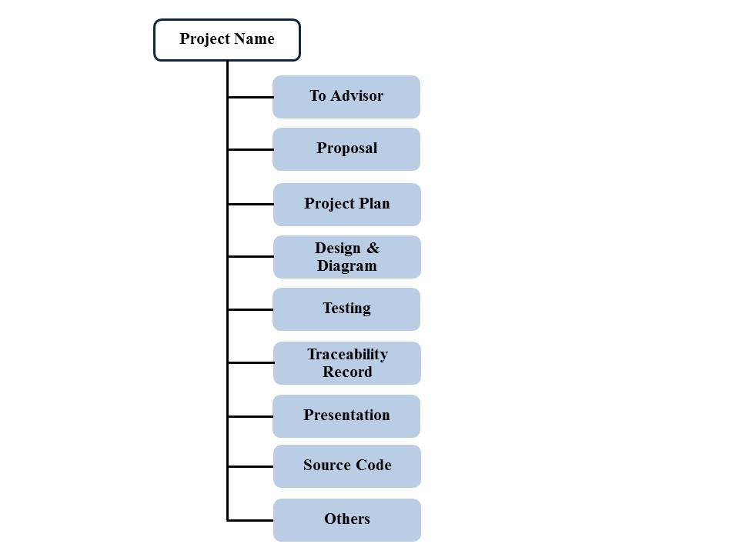

**Figure 3: Repository of OEGP**

**List of related document and description**

* To Advisor: contain document files that will be waiting to be reviewed by advisor.
* Proposal: contain involving proposal files.
* Project plan: contain project plan document files.
* Design & Diagram: contain design and diagram document files.
* Testing: contain testing document files.
* Traceability record: contain traceability record document
* Presentation: contain presentation files.
* Source code: contain source code of project.
* Others: contain kind of picture, server information, interesting web site and etc.

## 7.3 Configuration Item Table

|  |  |  |  |  |  |  |
| --- | --- | --- | --- | --- | --- | --- |
| **No.** | **Item** | **File Name** | **File Type** | **Owner** | **Path** | **Baseline** |
| 1 | Project Proposal | OEGP –ProjectProposal_V.1.0 | .docx | Panupak, Narongrit | Proposal | 1.0 |
| 2 | Development and Quality Plan | OEGP -Project Plan_V.1.0 | .docx | Panupak, Narongrit | Project Plan | 1.0 |
| 3 | Software Requirement Specification | OEGP –Software requirement specification _V.1.0 | .docx | Panupak, Narongrit | Design&Diagram | 1.0 |
| 4 | Software Design Document | OEGP –Software design document-V.1.0 | .docx | Panupak, Narongrit | Design&Diagram | 1.0 |
| 5 | Test Plan | OEGP -Test Plan_V.1.0 | .docx | Panupak, Narongrit | Testing | 1.0 |
| 6 | Test Record | OEGP -Test Record_V.1.0 | .docx | Panupak, Narongrit | Test Record | 1.0 |
| 7 | Traceability Record | OEGP -Traceability Record_V.1.0 | .docx | Panupak, Narongrit | Traceability Record | 1.0 |
| 8. | Software Source Code | OEGP-Software source code _V.1.0 | .zip | Panupak, Narongrit | Source code | 1.0 |
| 9. | 30 seconds video | OEGP- Show pro Video_V.1.0 | .avi | Panupak, Narongrit | Other/Showpro video | 1.0 |
| 10. | Poster size A1 | LTAS-Poster_V.1.0 | .png | Panupak, Narongrit | Other/Poster | 1.0 |

# Chapter 11 | Risk Management

Risk management is concerned with identifying risks and drawing up plans to minimize their effect on the project.  
 A risk is probability that some adverse circumstance will occur.  
 - Project risks affect schedule or resources.

- Product risks affect the quality or performance of the software being developed.

- Business risks affect the project team during developing or procuring the software.

Identified risks at the start of project and at the start of development phase. All identified risks are documented and assessed in the Risk Management Process by the Project Team. In the Risk Management Process defines the possible risks and solution of them, and who is responsible for.

## 11.1 Risk Management Process

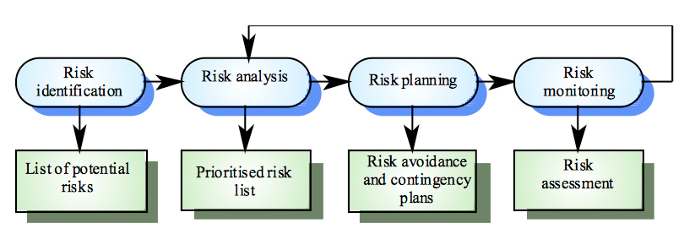

**Figure 3: Risk Management Process Model**

1. Risk identification: identify project, product and business risks.  
 2. Risk analysis: Assess the likelihood and consequences of the risks.  
 3. Risk planning: Draw up plans to avoid or minimize the effects of the risks.  
 4. Risk monitoring: Monitor the risks throughout the project.

## 11.2 Risk Identification and Solutions

|  |  |  |
| --- | --- | --- |
| **No.** | **Risk statement** | **Risk Solution** |
| 1. | The requirements might be change. | * Meeting and discuss and do a priority of changed requirements. * Design system with flexible requirements and related with the other requirements. |
| 2. | The deliverables maybe delay. | * Try to study more hard than previous work. * Ask a professional to make faster understand. |
| 3. | Budget of developing may not enough. | * Ask for more budgets from project advisor. |
| 4. | Work products are not submitted on time. | * Establish the project plan. * Develop project follow the project plan. |